**Organic form of soil nitrogen**

Over 90% of the nitrogen N in the surface layer of most soils occurs in organic forms,

with most of the remainder being present as NH4- whichis held within the lattice structures of clayminerals. The surface layerof most cultivated soils contains between0.06 and 0.3% N. Peat soils have high N contents to 3.5%.

Plant remains and other debris contribute nitrogen N in the form of:

**Amino acids**

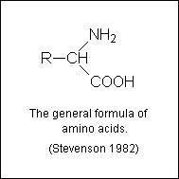

Amino acids exist in soil in several different forms, like:

1. As free amino acids
   * in the soil solution
   * in soil micropores
2. As amino acids, peptides or proteins bound to clay minerals
   * on external surfaces
   * on internal surfaces
3. As amino acids, peptides or proteins bound to humic colloids
   * H-bonding and van der Waals' forces
   * in covalent linkage as quinoid-amino acid complexes
4. As mucoproteins
5. As a muramic acid

Amino acids, being readily decomposed by microorganisms, have only anephemeral

existence in soil. Thus the amounts present in the soil solutionat any one time represent a balance between synthesis and destruction by microorganisms.

The free amino acids content of the soil is strongly influenced by weatherconditions,

moisture status of the soil, type of plant and stage of growth,additions of organic residues, and cultural conditions.

**Amino sugars**

Amino sugars occur as structal components of a broad group of substances, the

mucopolysaccharides and they have been found in combination with mucopeptides and mucoproteins. Some of the amino sugar material in soil may exist in the form of an alkali-insoluble polysaccharide referred to as chitin.

Generally the amino sugars in soil are of microbial origin.From 5 to 10%of the N in the

surface layer of most soils can be accounted for in N-containing carbohydrates or amino sugars.

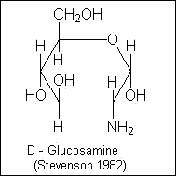

**Nucleic Acids**

Nucleic acids, which occur in the cells of all living organisms, consist of individual

mononucleotide units (base-sugar-phosphate) joined by a phosphoricacid ester linkage through the sugar.Two types: ribonucleic acid (RNA) anddeoxyribonucleic acid (DNA).They have pentose sugar (ribose or deoxyribose),the purine: adenine, guanine and the pyrimidine: cytosine, thymine.RNA contains also the uracil.

The N in purine and pyrimidine bases is usually considered to account forless than 1% of

the total soil N.

Small amounts of N are extrcted from soil in the form of **glycerophosphatides, amines,**

**vitamins, pesticide** and **pesticide degradation products.**

**Nitrogen transformation**

A key feature of the internal cycle is the biological turnover of N betweenmineral and

organic forms through the opposing processes of mineralizationand immobilization. The latter leads to incorporation of N into microbial tissues. Whereas much of this newly immobilized N is recycled through mineralization, some is converted to stable humus forms.

The overall reaction leading to incorporation of inorganic forms of N intostable humus

forms is depicted on the picture.

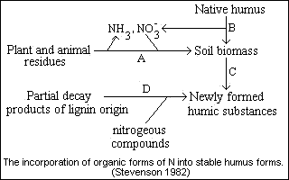Thus the decay of plant and animal residues by microorganisms results in theformation of mineral forms of N (NH4+ and NO3-) and assimilation of part ofthe C into microbial tissue (reaction A). Part of the native humus undergoes a similar fate (reaction B). Subsequent turnover through mineralization-immobilization leads to incorporation of N into stable humus forms (reaction C). Stabilization of N may also occur through the reaction of partial decay products of lignin with nitrogenous constituents (raection D).  
Except under unusual circumstances, both mineralization and immobilizationalways function in soil, but in opposite direction.

**Chemical reaction of ammonia and nitrite with organic matter**

The fate of mineral forms of N in soil is determined to some extent bynonbiological

reactions involving NH4+, NH3and NO2- as depicted in fig.

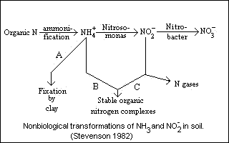In addition to NH4+ fixation by clay minerals (reaction A), NH3 and NO2- react chemically with organic matter to form stable organic N complexes(reaction B and C). The chemical interaction of NO2- with organic matter may lead to the generation of N gases. Although both types of reactions can proceed over a wide pH range, fixation of NH3+ is favored by a high pH (>7.0). In contrast, NO2- -organic matter interactions occur most readily under highly acidic conditions (pH of 5.0 to 5.5 or below).

**Stability of soil organic nitrogen**

1. Proteinaceous constituents are stabilized through their reaction withother organic constituents, such as lignins, tanins, quinons.

2. Biologically resistant complexes are formed in soil by chemical reactionsinvolving NH3+ or NO2- with lignins or humic substances.

3. Adsorption of organic N compounds by clay minerals (pariculary montmorillinitic types) protects the molecule from decomposition.

4. Complexes formed between organic N compounds and polyvalent cations, such as Fe, are biologically stable.

5. Some of the organic N occurs in small pores or voids and is physicallyinaccessible to microorganisms.

**C/N ratio**

For surface soils, and for the top layer of lake and marine sediments, the ratio generally

falls within well-defined limits, usually from about10 to 12. In most soils, the C/N ratio decreases with increasing depth, often attaining values less than 5.0.Native humus would be expected to have a lower C/N ratio than most undecayedplant residues for following reasons. The decay of organic residues by soilorganisms leads to incorporation of part of the C into microbial tissue with the remainder being liberated as CO2. As a general rule, about one-third of the applied C in fresh residues will remain in the soil after the first few months of decomposition. The decay process is accompanied by conversion of organic form of N to NH3 and NO3- and soil microorganisms utilize partof this N for synthesis of new cells. The gradual transformation of plantraw material into stable organic matter (humus) leads to the establishmentof reasonably consistent relationship between C and N. Other factors which may be involved in narrowing of the C/N ratio include chemical fixation of NH3 or amines by ligninlike substances.

The C/N ratio of virigin soils formed under grass vegetation is normally lower than for

soils formed under forest vegetation, and for the latter,the C/N ratio of the humus layers is usually higher than for the mineral soil proper. Also the C/N ratio of a well-decomposed muck soil is lower than for a fibrous peat.

As a general rule it can be said that conditions which encourage decompositionof organic

matter result in narrowing of the C/N ratio. The ratio nearly alwaysnarrows sharply with depth in the profile; for certain subsurface soils C/Nratios lower than 5 are not uncommon.